211 Walnut Street
Neenah, WI 54956

AN ORDINANCE: By the Neenah Plan Commission
Re: Rezoning 2.538 Acres of land south of Oakridge Road from R-1, Single-Family Residence District to the Calvary Bible Church PDD.

ORDINANCE NO. 2016-14
Introduced: November 2, 2016
Committee/Commission Action:
RECOMMENDED FOR PASSAGE

An Ordinance
The Common Council of the City of Neenah, Wisconsin, do ordain as follows:

Section 1. Section 26 of the Neenah Municipal Code of the City of Neenah pertaining to zoning districts, and the map therein described, is hereby amended by rezoning 13.806 acres of land north of Dogwood Trail from Cottages at Woodside Green PDD, Planned Development District to R-1, Single-Family Residence District. The property is further described as follows:
A part of the SW ¼ of the SE ¼ of Section 20, Township 20 North, Range 17 East, Town of Neenah, Winnebago County, Wisconsin containing 110,558 square feet (2.538 acres) of land being more fully described as follows:

Commencing at the South ¼ corner of Said Section 20; thence N89°26’51”E, 943.21 feet along the South line of the SE ¼ of said Section 20 to the SE corner of Lot 2 of Certified Survey Map No. 2999 as recorded in Volume 1 of Certified Survey Maps on Page 2999 as Document No. 885164 and the Point of Beginning; thence N00°01’21”W, 1107.86 feet along the East line of said Lot 2 to the NE corner thereof and the Southeasterly right-of-way line of Oakridge Road; thence N54°18’19”E, 127.16 feet along said Southeasterly right-of-way line to the South right-of-way line of the off ramp from Interstate “41” South bound as described in Document No. 829300; thence S82°43’17”E, 175.84 feet along said South right-of-way line; thence S35°52’20”E, 119.20 feet along said South right-of-way line to the Westerly extension of the South line of Certified Survey Map No. 1599 as recorded in Volume 1 of Certified Survey Maps on Page 1599 as Document No. 662639; thence S89°37’45”W, 272.54 feet along said Westerly extension to the East line of Lands described in Document No. 1301907; thence S00°01’21”E, 1060.69 feet along said East line to the South line of the SW ¼ of said Section 20; thence S89°26’51”W, 75.00 feet along said South line to the Point of Beginning.
Section 2. Severability. In the event any section, subsection, clause, phrase or portion of this ordinance is for any reason held illegal, invalid or unconstitutional by any court of competent jurisdiction, such portion shall be deemed a separate, distinct and independent provision, and such holding shall not affect the validity of the remainder of this ordinance. It is the legislative intent of the Common Council that this ordinance would have been adopted if such illegal provision had not been included or any illegal application had not been made.
Section 3. Repeal and Effective Date. All ordinances or parts of ordinances and resolutions in conflict herewith are hereby repealed. This ordinance shall take effect from and after its passage and publication.

Adopted: November 2, 2016

Published: November 22, 2016
Approved:

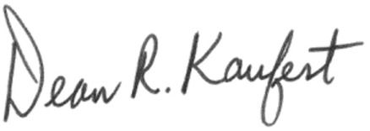
Dean R. Kaufert, Mayor

Attest:

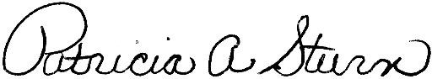
Patricia Sturn, City Clerk

